

Installing Kubernetes Dashboard
DevOps Certification Training

support@intellipaat.com
+91-7022374614
US: 1-800-216-8930(Toll Free)

INSTALLING KUBERNETES DASHBOARD
Steps for Master

Step 1: For installing Kubernetes Dashboard, run the following command:
$ kubectl create -f https://raw.githubusercontent.com/kubernetes/dashboard/master/aio/deploy/recommended/kubernetes-dashboard.yaml

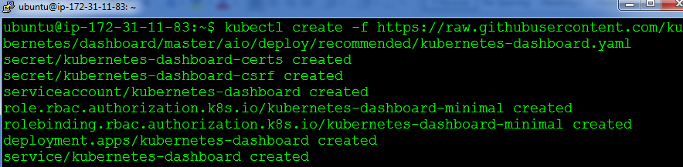

Step 2: Edit the Kubernetes Dashboard service with this command
$ kubectl edit svc kubernetes-dashboard –n kube-system

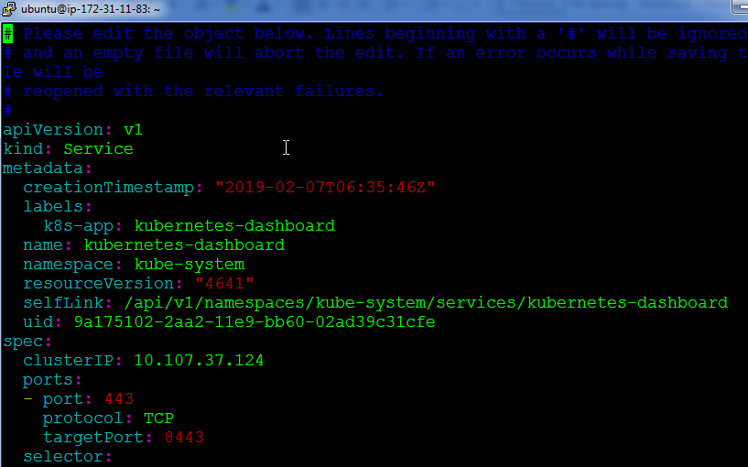

Step 3: Change the text “clusterip” to “nodeport”, once done save and exit.
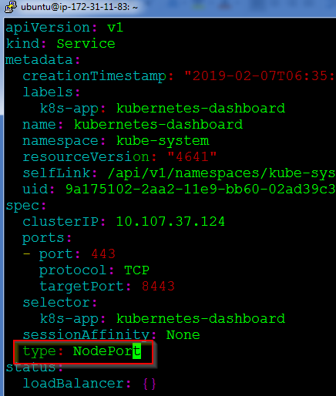

Step 4: Finally note down the IP address of the kubernetes-dashboard service using the following command:
$ kubectl get svc kubernetes-dashboard –n kube-system

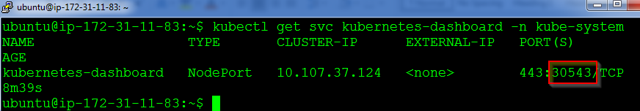

Step 5: Next browse, to the following address, to the see the login page of the dashboard:
https://<ip-address-of-master-or-slave:<nodeport>

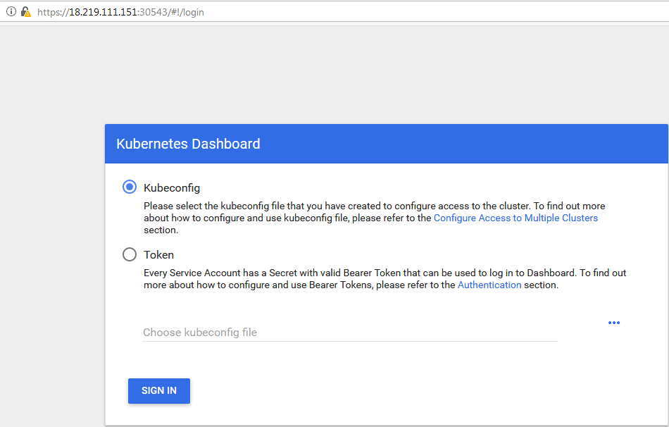

Step 6: For logging in , use the following commands:
# Create service account
kubectl create serviceaccount cluster-admin-dashboard-sa
# Bind ClusterAdmin role to the service account
kubectl create clusterrolebinding cluster-admin-dashboard-sa \
--clusterrole=cluster-admin \
--serviceaccount=default:cluster-admin-dashboard-sa
# Parse the token
TOKEN=$(kubectl describe secret $(kubectl -n kube-system get secret | awk '/^cluster-admin-dashboard-sa-token-/{print $1}') | awk '$1=="token:"{print $2}')

Step 7: Now pass the following command, to view the token:
echo $TOKEN

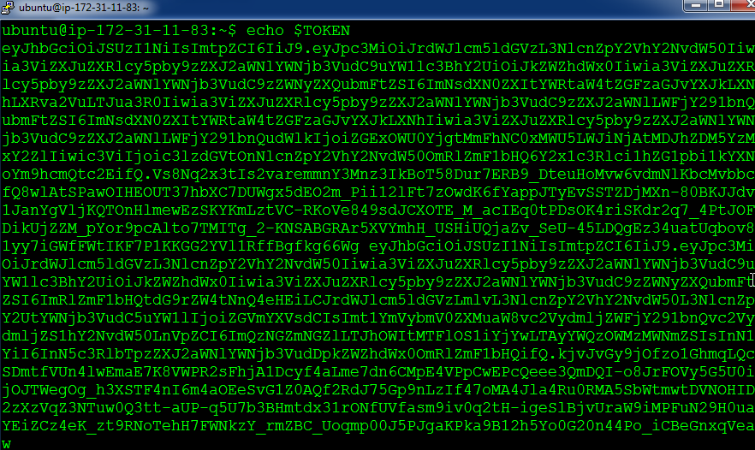

Step 8: Copy this token and paste it in the login page of Kubernetes Dashboard:
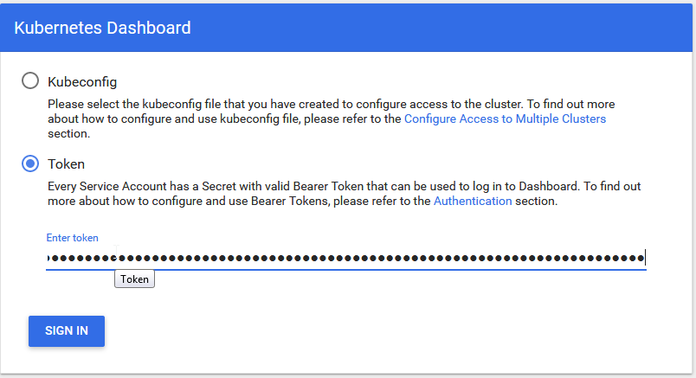

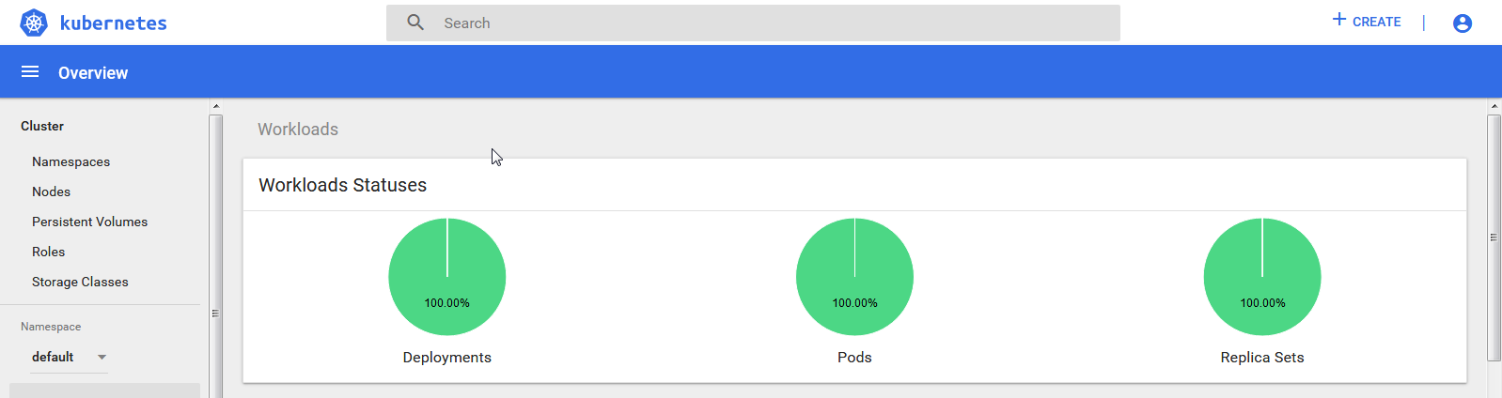

Kubernetes Dashboard is now successfully installed!

